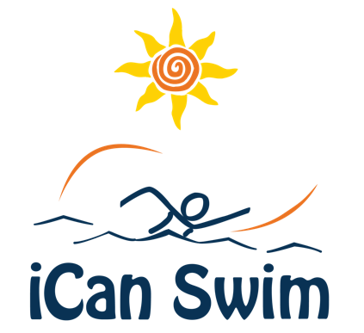

Camp Press Release

FOR IMMEDIATE RELEASE - [Date]

SWIM camp for INDIVIDUALS with disabilities NOW ACCEPTING applications

iCan Shine is a non-profit organization that provides recreational programs for individuals with disabilities. Our iCan Swim program focuses on helping each participant age 3 and older work toward their individual aquatic goals. We work on learning new swim skills, improving existing skills with a daily emphasis on life-saving water safety skills in and around aquatic environments. This five-day camp, requiring swimmers to attend only one 45-minute or 60-minute session per day depending on age, is taking place [dates and location].

iCan Shine collaborates with local organizations to host five-day camps in their communities. This camp is being hosted by [Brief description of your organization and mission].

To be eligible to enroll, swimmers must: be at least three years old and have a disability. All abilities are welcome however individuals with a tracheostomy are not eligible to participate as we are unable to guarantee a splash-free environment.

Cost of the swim camp is $[ ].

FOR MORE INFORMATION, CONTACT:

[Host contact(s) name, phone, email]

