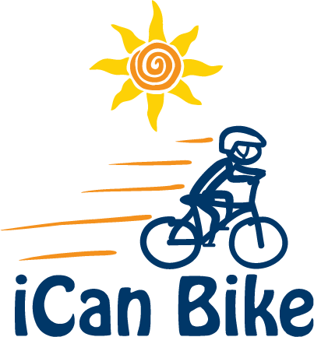

[Or Host Letterhead]

Bike Shop Solicitation Sample

Hi [Bike Shop Owner or Manager]

We are hosting a five-day iCan Bike camp this summer to teach local children and young adults with disabilities how to ride a bicycle. The bike camp is conducted, through collaboration with [us or our organization] as the local host, by a national nonprofit organization, iCan Shine, that uses custom-designed and built adapted biking equipment

We will have a total of [xx] local riders and [xx] local volunteers at our bike camp that is scheduled to take place [dates and location of bike camp]. The vast majority of such families will need to purchase a bicycle, helmet and accessories for their participant and possibly other members of their family.

We’re trying to identify and collaborate with a local bicycle shop in connection with our bike camp. Such mutually beneficial collaboration would work as follows:

- We share with the bike shop a 10-minute video entitled ‘Selecting the Most Suitable Bike for Learning’ found on the iCan Shine website at https://icanshine.org/parents/ican-bike-parents/ and a 4-page document entitled ‘Considerations when Fitting Individuals with Disabilities for Bikes’ found at https://icanshine.org/program-hosts/ican-bike-hosts/ detailing specific and suggested models of bikes by size.

- We announce to all participating families that your bike shop is supporting our local iCan Bike camp and encourage all such families to purchase their bicycles from your bike shop

- Bike Shop representative/liaison attends our parent orientation meeting for 30 minutes the Sunday evening before camp starts. The objective is to listen to the iCan Shine Bike Technician’s presentation to parents about details on how to purchase an appropriate bike for their special rider. The presentation is a reiteration of the 10-minute video and document mentioned above.

- Bike Shop agrees to watch the 10-minute video and read the 4-page document mentioned above and sell bikes to our iCan Bike families that are appropriate for their rider.

This is a win/win partnership for everyone involved:

- It helps the bike shop by providing the opportunity to obtain and help numerous local customers currently in the market to purchase a bike, helmet and related accessories for their rider and possibly other family members

- It helps the families and riders because they know if they buy from your bike shop, they will get quality and personalized service and leave with an appropriate bike for their special rider (as opposed to entering a Walmart, Toys R Us or Target to buy a poorly made bike that is inappropriate for their rider)

- It helps the host and iCan Shine because it ensures the bikes brought to camp by the parents will be appropriate for our special riders avoiding the need for the family to return and exchange the bike during camp

- Finally, it is a great local cause for your bike shop to be front and center supporting and promoting bike riding and inclusion among local people with disabilities

Although discussed in the 10-minute video and accompanying document discussed above, some examples of specific bicycle features that help people with disabilities more comfortably ride a bike include:

- shorter radius of pedal shaft (easier to pedal while seated)

- single speed bicycles (e.g. Beach Cruisers for 24” and 26” sizes)

- meaningful height difference between the handle bars and seat for a more upright posture (makes it easier to steer and control)

- removal of front tire hand brake on smaller bikes (16” and 20”) to avoid falls over handlebars from abrupt stops

- all bikes should have a hand brake because this is the method of braking taught to our riders at our iCan Bike camps (connected to back tire only on 16” and 20” bikes)

- we also encourage coaster brakes, not for braking but instead to prevent the pedals from spinning in reverse for consistency in what we teach “feet make you go” and “hands make me stop”.

For more information on iCan Bike programs and to view some short professionally produced television news videos of such camps in action, please visit www.icanshine.org

Please e-mail or give me a call if you are interested. I look forward to hearing from you!

Thank you,

[Camp Host/Director]

