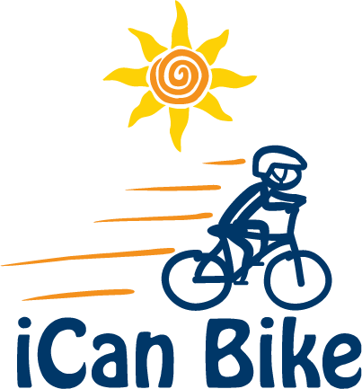

E-mail Confirmation of Volunteer Registration

Hi [Volunteer Name]

You are confirmed to volunteer as a spotter at the iCan Bike camp at [Facility name and address] the week of [camp dates] for the following session(s):

- [Session #2: 10:05 am – 11:20 am]

It is very important that you arrive 20 minutes before your session start time each day. This will give you time to check in, get a nametag and be ready for your daily volunteer meeting that will begin promptly 15 minutes before each session. During this daily meeting you will be provided with the plan and goals for that day, as well as techniques and instructions for spotting your specific rider.

As a reminder, please wear comfortable, active clothes (shorts, t-shirt and sneakers) and note that open-toe shoes are not permitted.

Please plan to attend the orientation and volunteer training meeting on Sunday taking place at [Location, date and time]. During this orientation you will receive an overview of how the iCan Bike program works, instructions on how to work with our adapted bicycles and strategies for working with your assigned rider.

Click the below link to access the iCan Bike website for more information and to view some short videos (on the home page) of the iCan Bike camp in action:

www.icanshine.org

I will be in touch periodically via e-mail as bike camp approaches. Please inform me of any changes in your ability to volunteer or availability. Your assigned rider and their parent will be counting on your attendance!

I look forward to meeting and working with you!

Best Regards,

[Host Name]

