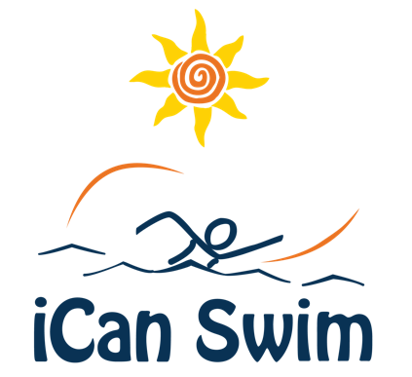

Swimmers and Volunteers Needed!

Where and When: [Location and Date]

Swim Program: iCan Shine is a nonprofit organization that provides quality recreational programs for individuals with disabilities. iCan Swim is designed to help people achieve their aquatic goals and learn valuable water safety skills during the weeklong program.

Swimmer Requirements (limited spots available):

- Must be at least 3 years old by start of camp and have a disability

Volunteer Requirements:

- At least 15 years old (unless accompanied by an adult)
- Able to attend each of the 5 days of camp. 45 minutes for the 3-7 year old session and 60 minutes for the other sessions (15 minutes of training/daily debriefing)
- Able to provide physical, emotional and motivational support to assigned swimmer
- Must be able to swim and comfortable in the water
- Able and willing to get some exercise in the pool for a great cause!

To register for this great program as a swimmer or volunteer go to [your camp webpage].

If you have questions please e-mail us at [Host e-mail].

