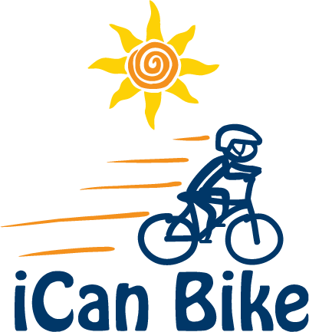

Response to iCan Bike Volunteer Inquiry

Hi [Inquirer Name]

Thank you for your request for information on volunteering for our bike camp scheduled for [Dates and Location].

To give you an overview, we will have approximately [ ] riders in total at camp but no more than [ ] riders at any one time during the five separate 75-minute daily sessions.

The riders will be riding a specialized adapted bicycle designed to teach them to balance appropriately for the entire 75 minutes each day while being accompanied by their two assigned volunteers. Additionally, camp staff will provide fun motivational teaching on a specially designed tandem bike that is generally well received by most riders.

The first two days of the bike camp (Mon & Tues) will take place solely inside on adapted roller bikes. Beginning on the third day (Wed), some riders may graduate to a two-wheel bike and transition to riding outdoors spotted by their assigned volunteers while most riders will continue riding the adapted roller bikes indoors. As riders graduate from the roller bikes to a two-wheel bike between Wednesday and Friday, they will transition to the outdoor riding area.

Each rider attends the same 75-minute session for each of the 5 days (M – F) and is assigned the same two volunteers that will work with the rider throughout the week. This works great because bonds are formed between the volunteers and riders helpful for encouragement and motivational purposes throughout the week. It is important for our riders to work with the same volunteer each day building a trusting relationship as they progress through the week.

It is very rewarding for the volunteer to have spent the whole week with the same rider to see the fruits of their labor on the last day when the rider finally rides independently.
It is important to note that volunteer spotters will walk/jog approximately 3 miles during each 75-minute session so please keep this in mind if considering volunteering for multiple sessions. Unless you are very athletic, please do not volunteer for more than two (2) 75-minute sessions per day.

We ask volunteers to commit to attending all 5 days of camp for the session(s) selected. Riders bond with their assigned volunteers and rely on the same person to be there to support them each day of camp

Daily 75-Minute Sessions:

[8:30 am - 9:45 am]
[10:05 am - 11:20 am]
[11:40 am - 12:55 pm]
[2:00 pm - 3:15 pm]
[3:35 pm - 4:50 pm]

Volunteers are encouraged to attend a 45-minute orientation on [insert Date and Time] at [insert Address]. During this orientation, you will learn about how the iCan Bike program operates, what to expect each day in your role as a volunteer spotter and you will receive training tips on spotting your assigned rider. There will also be an opportunity to ask questions and meet other volunteers in your session. This orientation meeting is highly encouraged but not mandatory.

Volunteers arrive each day of camp 15 minutes prior to their session start time for a daily strategy/briefing session.

Click the below link for access to the iCan Bike website for more information and to view a number of short videos of the iCan Bike camp:

www.icanshine.org

I hope this provides you with helpful information about the program. I attached a registration form that provides all the information you need to know about registering to be a volunteer spotter.

Sincerely,

[Camp Host/Director]

