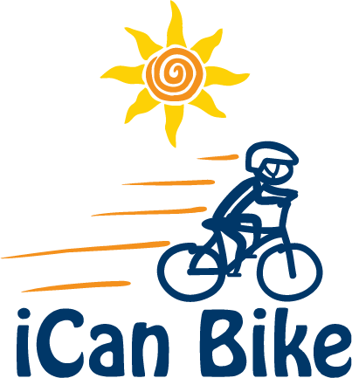

E-mail Response to Parent/Guardian of Rider Inquiry

Thank you for your request for information on our iCan Bike camp scheduled for [Dates and Location].

Click the below link for access to the iCan Bike website for more information and to view a number of short videos (on the home page) of the iCan Bike camp:

www.icanshine.org

iCan Bike Program Overview:

- We will have approximately [ ] riders in the total camp; however, because there are five 75-minute sessions each day, there will be no more than [ ] riders at any one time at camp which ensures more individualized attention for your rider

- Each rider, accompanied by their parent or guardian, will attend the same 75- minute session each day

- We will seek to provide the same volunteers all week for your rider to create a familiar, predictable and safe environment

- Riders will begin on a specialized adapted bicycle (roller bike) designed to teach them to balance appropriately

- On the second day of camp, in addition to riding the roller bike, riders will participate in a specialized tandem bike ride with iCan Bike staff which provides motivation as well as instructional opportunities

- The first two days of bike camp (Mon & Tues) will take place solely inside on the adapted roller bikes

- Roller bikes gradually introduce increased instability to riders as the different rollers are introduced enabling riders to sequence through such bikes at their own individual pace

- On the third day (Wed), some riders may transition to a conventional two-wheel bike once they have sequenced through the roller bikes

- Once riders are initially successful on a conventional two-wheel bike (demonstrate good balance and ability to brake and stop), they will transition to the outdoor riding area with their volunteer supporters

- The process of transitioning to a two-wheel bike riding outside may happen Wednesday, Thursday or Friday and is based on each rider’s individual pace through our sequence of roller bikes

Five daily 75-minute sessions:

- [8:30 am - 9:45 am]

- [10:05 am - 11:20 am]

- [11:40 am - 12:55 pm]

- [2:00 pm - 3:15 pm]

- [3:35 pm - 4:50 pm]

Rider must meet all of the following requirements:

- Have a disability

- At least 8 years old at the start of camp

- Maximum weight of 220 lbs

- Able to walk without assistive device

- Able to sidestep to both sides

- Minimum inseam of 20” (measure from floor while wearing sneakers)

- Willing and able to wear a properly fitted bike helmet

- Able to attend the same 75-minute session for all 5 days of camp

Parent/guardian reminders:

- A parent or guardian must remain present at camp at all times during each 75-minute session (dropping off the rider is not permitted)

- Riders will need their own two-wheel bike to transition to at the end of the camp week. This bike needs to be brought to camp no later than the fourth day (Thursday).

I hope this provides you with helpful information about the program.

[Provide registration information, forms or links]

Sincerely,

[Camp Host/Director]

