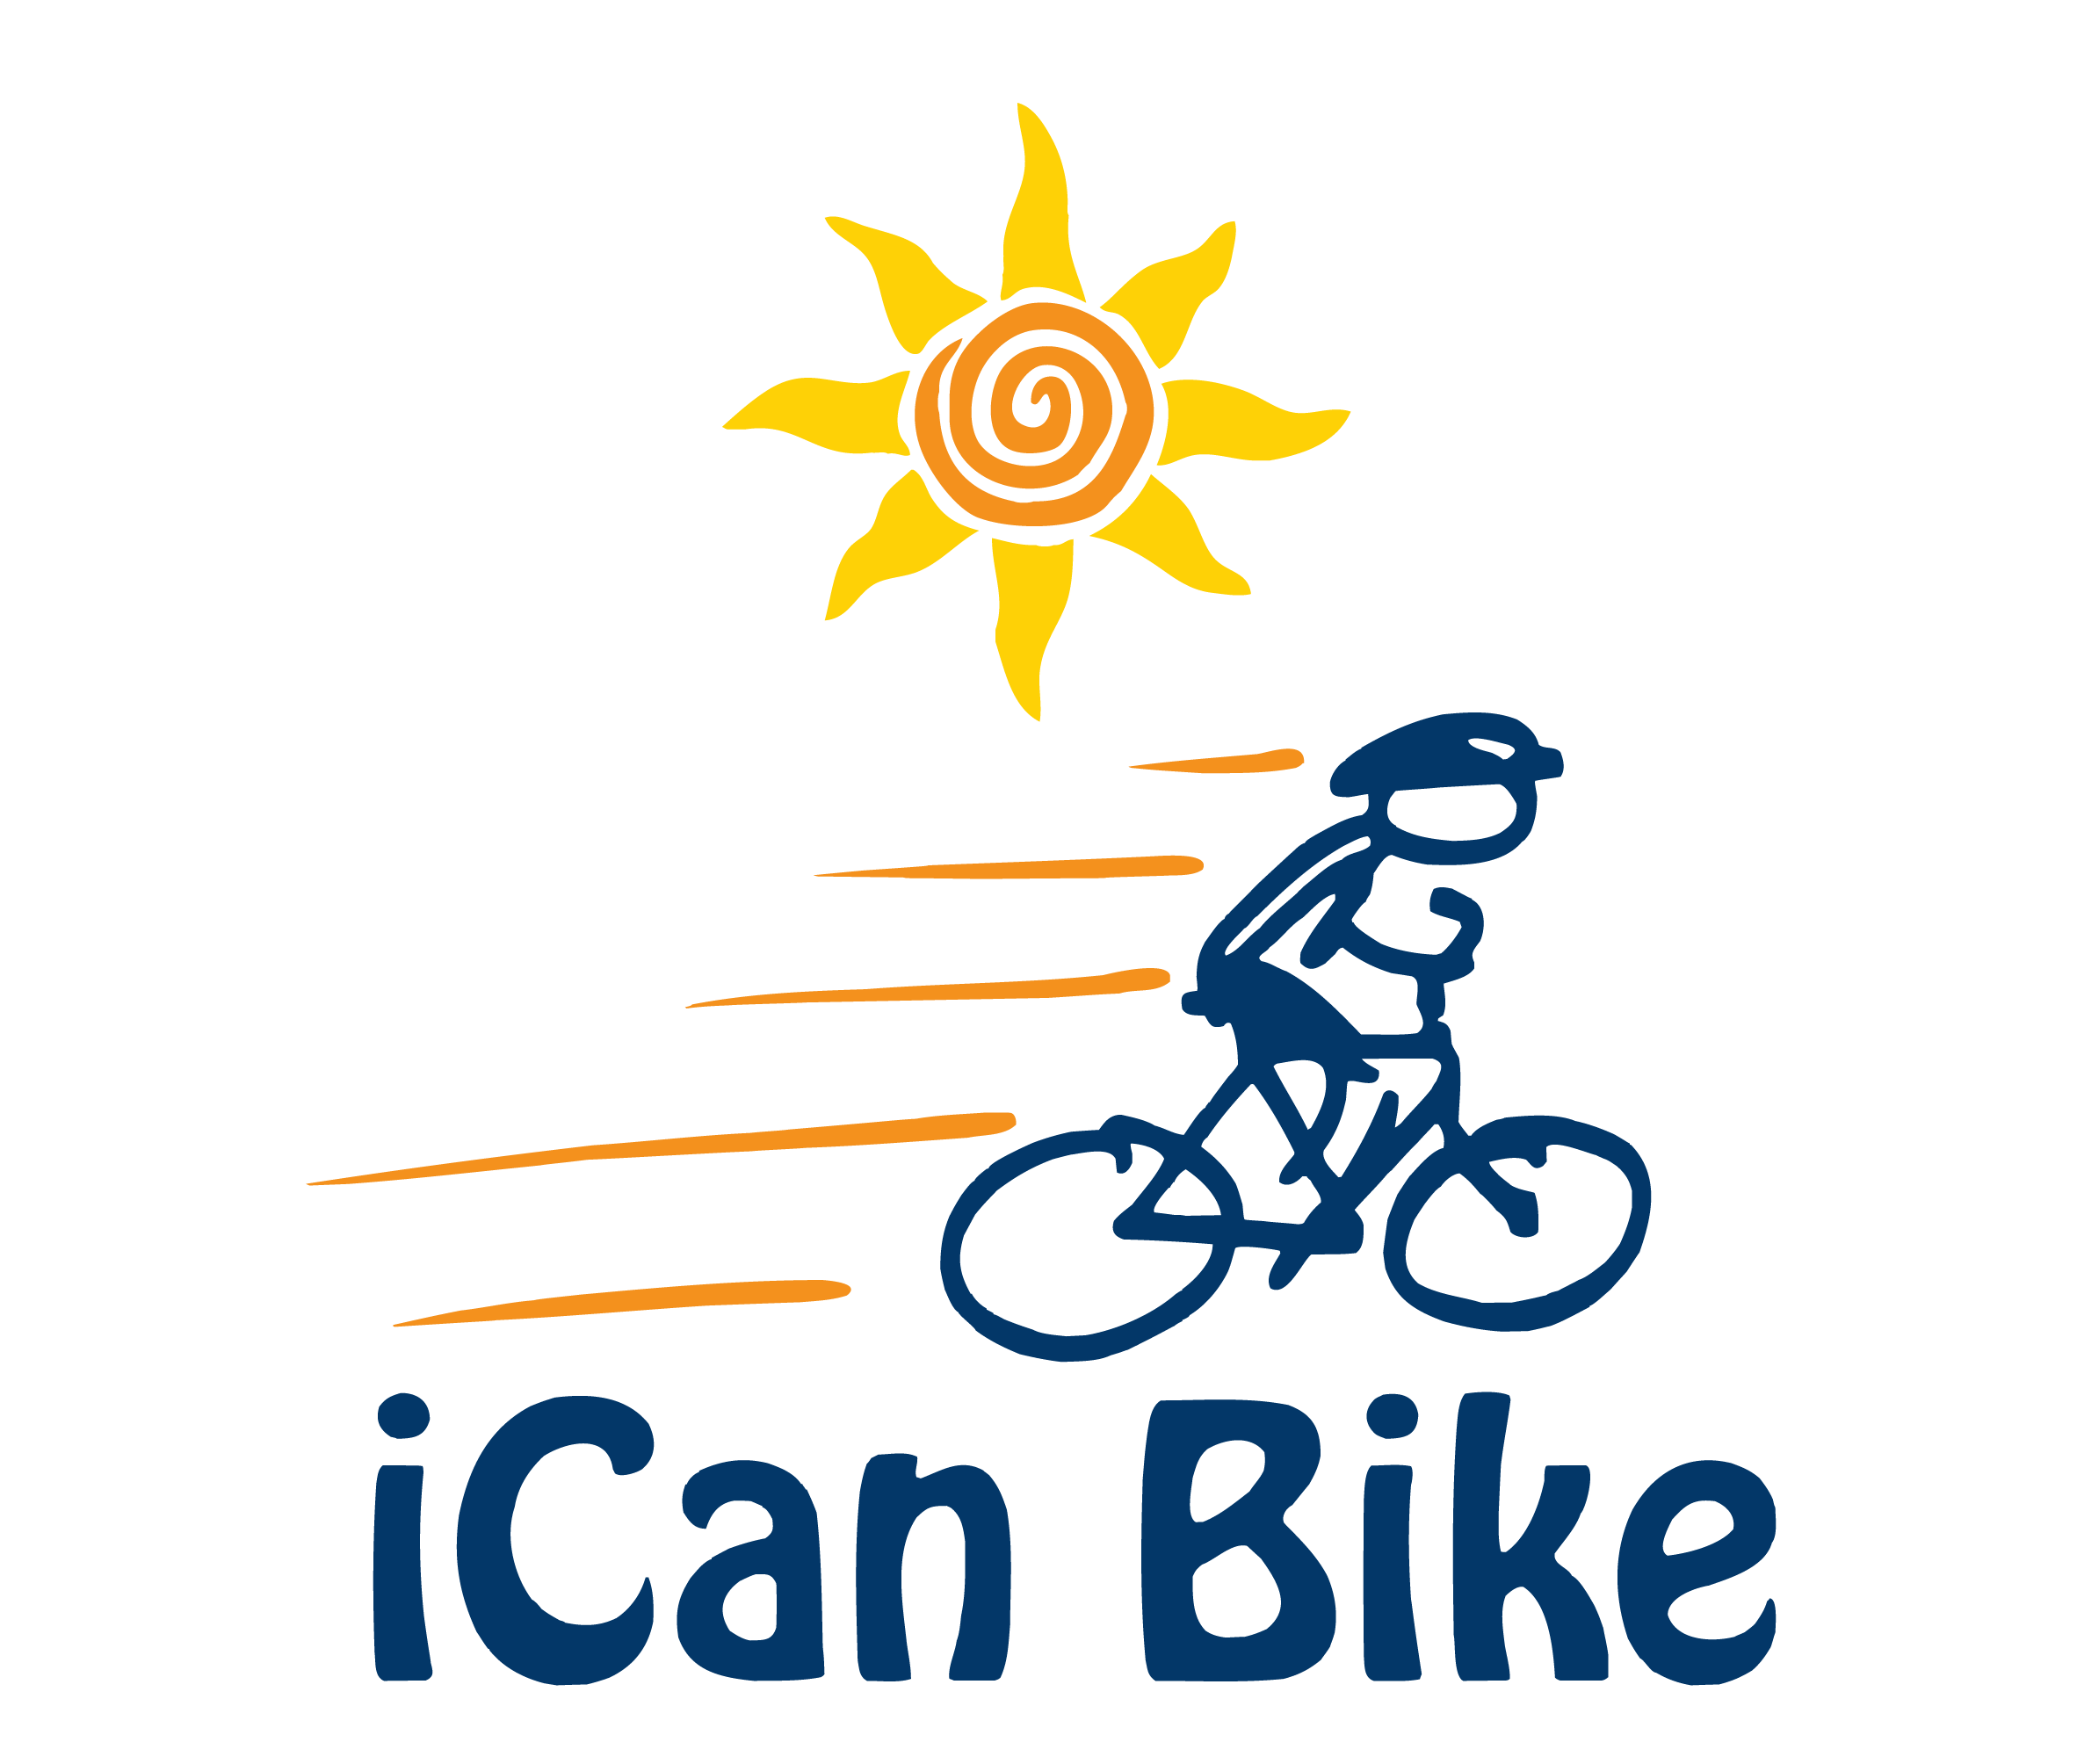

Riders and Volunteers Needed!

Where and When: [Location and Date]

Bike Program: iCan Shine is a nonprofit organization that teaches individuals with disabilities to ride a conventional two-wheel bicycle through its’ iCan Bike program.

Rider Requirements (limited spots available):

- Must be at least 8 years old by start of camp and have a disability
- Must be able to walk without an assistive device and sidestep to both sides
- Must be able to attend the same 75-minute session each day of the 5-day camp
- Must be under 220 lbs. and have a minimum inseam measurement of 20” (measure from floor with sneakers on)

Volunteer Requirements:

- At least 15 years old (unless accompanied by an adult)
- Able to attend 90 minutes at the same time each of the 5 days of camp (15 minutes of pre-session meeting/training)
- Able to provide physical, emotional and motivational support to assigned rider
- Able and willing to get some exercise (light jogging/running) for a great cause!

Those interested in registering for this great program as a rider or volunteer should e-mail us at [Host e-mail]. For more info go to: www.icanshine.org

