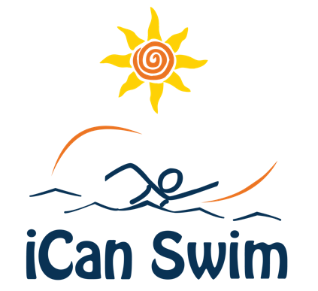

Swimmer Confirmation E-Mail

Hi [Parent/Guardian Name],

This is to confirm enrollment of [Swimmer Name] in the iCan Swim Camp the week of [Camp Dates] at the [Facility Name and Address]. [Swimmer Name] is scheduled for Session #[ ] from [start time] to [end time] each day of camp. Please ensure [Swimmer Name] arrives each day at least 10 minutes before the scheduled start time to allow time for changing and rinsing off if necessary, using the restroom and being ready to go at the start of the session.

How can I help my swimmer be prepared for camp?

- Bring a water bottle or drink and a snack for after the session
- Bring a towel
- If your swimmer wears a swim diaper please make sure you have extra diapers
at camp. Accidents do happen.
- Please DO NOT bring any flotation devices such as “floaties”, lifejackets, swim
fins, snorkels, or other devices as we will not use them during swim camp
- Goggles are acceptable at camp

Is there an Orientation Meeting?

There will be an orientation meeting for parents/guardians and volunteers on Sunday [Date, Time and Location]. We ask that swimmers not attend the orientation meeting.

The meeting will last approximately 35 minutes providing an opportunity for you to meet the iCan Swim staff, learn how the program works and how the camp operates, participate in a Q&A session and take a short tour of the facility.

Is my Registration Fee Refundable?

The refund policy for the camp is [Host policy here]. If you are unable to attend the camp at any point, please contact the Camp Director as soon as possible.

We will be in touch periodically between now and camp through e-mail. We look forward to the opportunity to meet you and work with your swimmer. If you have questions, please contact me at [Camp Director contact info].

Sincerely,

(Camp Director Name)

