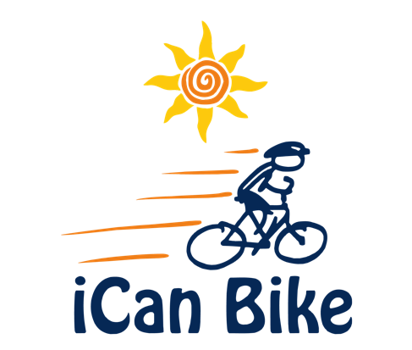

Bike Camp Press Release

FOR IMMEDIATE RELEASE - [Date]

bicycle camp for INDIVIDUALS with disabilities NOW ACCEPTING applications

iCan Shine is a non-profit organization that teaches individuals with disabilities to ride a conventional two-wheel bicycle using adapted bike equipment through it’s iCan Bike program. This five-day camp, requiring riders to attend only one 75-minute session per day, is taking place [dates and location].

iCan Shine collaborates with local organizations to host five-day camps in their communities. This camp is being hosted by [Brief description of your organization and mission].

iCan Shine uses customized adapted equipment, trained professionals and volunteers. With 75 minutes of instruction over five days, approximately 80% of riders learn to ride a conventional bicycle independently by the end of camp. The remaining 20% often make great progress towards that goal.

To be eligible to enroll, riders must: be at least eight years old; have a disability; be able to walk without an assistive device such as a walker or cane; be able to side-step quickly to both sides; have a minimum inseam measurement of 20 inches from the floor; and weigh no more than 220 pounds.

Cost of the camp is $[ ].

FOR MORE INFORMATION, CONTACT:

[Host contact(s) name, phone, email]

