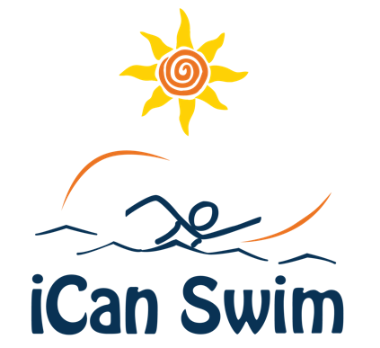

Volunteer Registration Confirmation E-Mail

Hi [Volunteer Name]

You are confirmed to volunteer at the iCan Swim camp at (Name and address of facility) the week of ( ) for the following session(s):

- [e.g., Session #1, 9:00am – 9:45am (please arrive at 8:45am)]
- [e.g., Session #3, 11:30 am- 12:30pm (please arrive at 11:15)am]

It is very important that you arrive 15 minutes before the session start time each day as we spend the first 15 minutes of each session having a volunteer meeting to discuss goals and techniques for working with each swimmer.

As a reminder, please wear a comfortable and appropriate swim suit, nothing too revealing please. It is common for children learning to swim to cling to you and grab at your swimsuit. If you feel more comfortable with a swim shirt or rash guard feel free to wear one.

Please plan to attend the 30-35 -minute Parent & Volunteer Orientation on Sunday at (facility name) at ( pm). The first portion of the presentation will include parents of swimmers so that everyone is prepared for Monday. The second portion of the Orientation will cover your volunteer training and last approximately 90 minutes. A portion of this training will take place in the pool. Please either wear your swimsuit or bring it along with a towel. We will have a 10-minute break for you to change if needed. This training is important as you will learn techniques to help your swimmer be most successful.

If you have any questions, please don’t hesitate to ask. I look forward to meeting and working with you. Thank you for your commitment to help people with disabilities learn to swim.

Best Regards,

(Camp Director Name)
(Email address)

