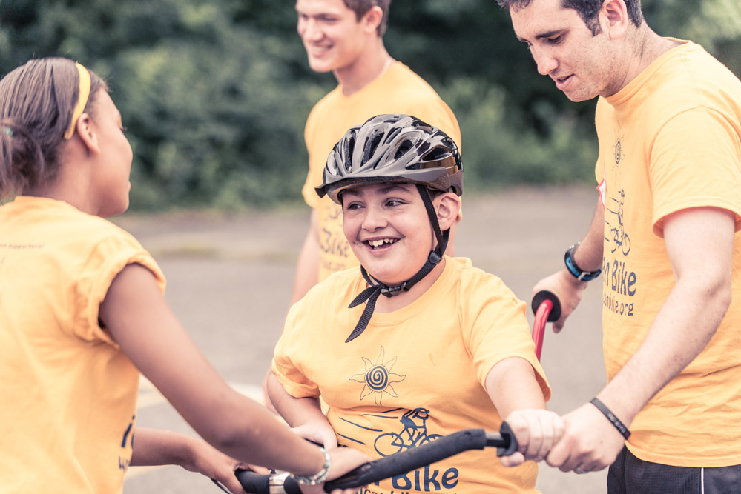
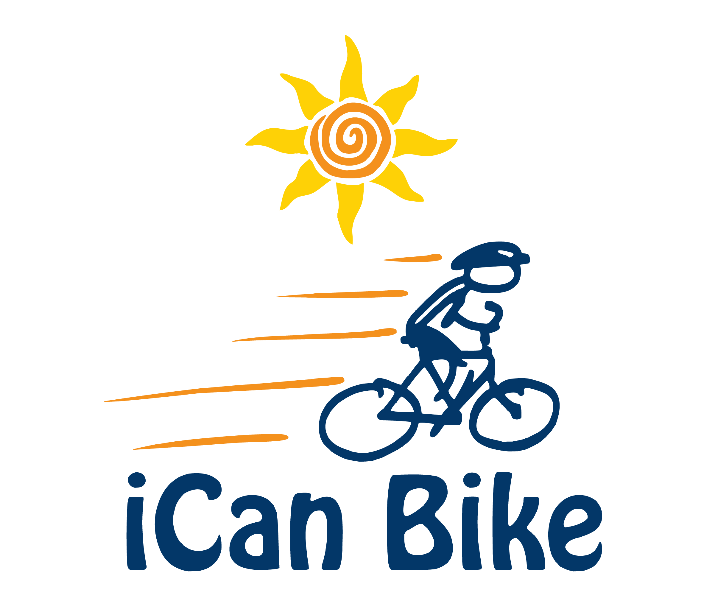

Dear Friend:
I would like to tell you about an opportunity for you to make a profound and meaningful contribution to children and young adults with disabilities right here in our area.
iCan Shine is a national charitable nonprofit organization which conducts over 100 five-day iCan Bike programs teaching approximately 3,000 people with disabilities how to ride a two-wheel bicycle each year. Since it’s inception in 2007, over 20,000 people with disabilities have learned to ride a bicycle through this wonderful program.
There is a great need for bicycle programs for people with disabilities. For example, research shows that approximately 80% of people with autism and 90% of people with Down syndrome never learn how to ride a bicycle during their lifetime. Learning to overcome the challenge of riding a bicycle benefits people with disabilities by enabling them to participate in a leisure activity with their friends and family, stay physically fit, gain confidence and improve their sense of accomplishment and self-esteem.
Using adapted custom-built bike equipment, trained professionals, and volunteers, participants in the five-day iCan Bike programs receive 75 minutes of daily instruction. What is truly amazing is that over 80% of the participants learn to ride a conventional bicycle independently by the end of the week!
I can assure you that this letter cannot adequately describe the moment during a camp when the volunteer lets go of the participant’s bike training handle for the first time: The rider smiles as broadly as they ever have, truly shining, the staff erupts in cheering, and the parents laugh and cry.
Take a look:
http://www.youtube.com/watch?v=5d82gFzxJOw&feature
Each of us can remember when we rode a bike for the first time - riding a bicycle is a personal success and freedom that we all take for granted. Children with disabilities don’t take this for granted and in many cases don’t even try. We are working to change that, city by city, one rider at a time. To accomplish our goals, we need your help.

How You Can Help!
We are very lucky to have the opportunity to host the iCan Bike program in [insert host community]. It will be held at [insert host facility and dates] and is hosted by [insert host name].
We need your help to make this program a big success. The program includes highly-trained staff along with lots of custom-built adapted bike equipment travelling from city to city each week via truck and trailer. We are looking for organizational sponsors as well as individual donors to help cover the cost of hosting this wonderful program in our community.
By making a tax-deductible donation, you can ensure that we have the funds we need to pay for the great staff and equipment to travel here, help us keep the fees for parents of participants to a minimum, offer scholarships for those families with financial need, and make sure that we have everything we need to make our camp as successful as it can be.
There are many options for sponsorship.
For example:
- $2,000 - Sponsor a session ([insert #] participants)
- $750 - Sponsor our t-shirts (provided to participants and volunteers)
- $250 – Sponsor a participant
- $150 – Sponsor participant awards (trophies/medals)
- Or choose any amount that fits your budget!
Whatever your donation, you will be helping kids in our community gain independence, self-esteem and inclusion opportunities with their family and community. You, your organization or company will be recognized on our t-shirts and promotional materials, and we welcome any promotional materials you might like to distribute or have us post at camp.
Please visit our website at [insert URL link to host iCan Bike webpage] for more information about our iCan Bike program and us. We rely on the generosity of caring people like you to make learning this life-long skill a reality for so many in need. It is life changing for the participants and for their families, offering opportunities to be just like everyone else.
Thank you for your time and support.
Sincerely,

[insert host name]

Please make checks payable to: [insert host name or iCan Shine if host plans to mail checks to Shine for deposit]

Mail checks to:

[insert host address]

Make a secure online donation to support our local iCan Bike camp at:

https://icanshine.org/donate-to-specific-camp-location/

